import java.io.\*;

import java.util.\*;

import java.applet.\*;

import java.awt.\*;

/\*<applet code="DTransformation.class" width=500 height=500>

</applet>

\*/

public class DTransformation extends Applet

{

public void init()

{ }

public void paint(Graphics g)

{

int n;

int x[]=new int[10];

int y[]=new int[10];

float xo[]=new float[10];

float yo[]=new float[10];

double pi=3.14;

int ch,tx,ty,sx,sy,ang,i,vch,gl;

String c;

Scanner sc = new Scanner(System.in);

do

{

System.out.print("Enter the no. of vertices : " );

n = sc.nextInt();

for(i=0;i<n;i++)

{

System.out.println("Enter co-ordinates for "+(i+1)+": ");

x[i] = sc.nextInt();

y[i] = sc.nextInt();

}

for(i=0;i<n-1;i++)

g.drawLine(x[i],y[i],x[i+1],y[i+1]);

g.drawLine(x[i],y[i],x[0],y[0]);

System.out.print("\n 1: Translation \n 2:Scaling \n 3: Rotation \n 4:reflexion \n Enter your choice : ") ;

ch=sc.nextInt();

switch(ch)

{

case 1 :

System.out.print("Enter <Tx> & <Ty> value : ");

tx=sc.nextInt();

ty=sc.nextInt();

for (i=0;i<=n;i++)

{

xo[i]=x[i]+tx;

yo[i]=y[i]+ty;

}

break;

case 2 :

System.out.print("Enter <Sx> & <Sy>value : ");

sx=sc.nextInt();

sy=sc.nextInt();

System.out.print("Enter Reference Vertex : ");

vch=sc.nextInt();

for(i=0;i<=n;i++)

{

xo[i]=(x[i]-x[vch-1])\*sx+x[vch-1];

yo[i]=(y[i]-y[vch-1])\*sy+y[vch-1];

}

break;

case 3 :

double t;

System.out.print("Enter Angle : ");

t=sc.nextInt();

System.out.print("Enter Reference Vertex : ");

vch=sc.nextInt();

t=t\*(pi/180);

for(i=0;i<n;i++)

{

xo[i]=((x[i]-x[vch-1])\*(float)Math.cos(t))-

((y[i]-y[vch-1])\*(float)Math.sin(t))+x[vch-1];

yo[i]=((x[i]-x[vch-1])\*(float)Math.sin(t))-

((y[i]-y[vch-1])\*(float)Math.cos(t))+y[vch-1];

}

break;

case 4:

System.out.println("if abt x axis enter 1 and for y axis enter2");

gl=sc.nextInt();

if(gl==1)

{

for(i=0;i<n;i++)

{

xo[i]=x[i];

yo[i]=y[i]+250;

}

}

if(gl==2)

{

for(i=0;i<n;i++)

{

xo[i]=x[i]-250;

yo[i]=y[i];

}

}

break;

default:

System.out.println("wrong entry");

break;

}

for(i=0;i<n-1;i++)

g.drawLine((int)xo[i],(int)yo[i],(int)xo[i+1],(int)yo[i+1]);

g.drawLine((int)xo[i],(int)yo[i],(int)xo[0],(int)yo[0]); System.out.print("Do you wanna coninue? y/n : ") ;

c = sc.next();

repaint();

}

while(c.equals("y")||c.equals("Y"));

}

}

Microsoft Windows XP [Version 5.1.2600]

(C) Copyright 1985-2001 Microsoft Corp.

C:\Documents and Settings\Administrator>cd/

C:\Documents and Settings\Administrator>d:

D:\>cd glancy

D:\glancy>javac DTransformation.java

D:\glancy>appletviewer DTransformation.java

Enter the no. of vertices : 3

Enter co-ordinates for 1:

100

300

Enter co-ordinates for 2:

300

300

Enter co-ordinates for 3:

200

100

1: Translation

2:Scaling

3: Rotation

4:reflexion

Enter your choice : 1

Enter <Tx> value : 100

Enter <Ty> value : 100

Do you wanna coninue? y/n : y

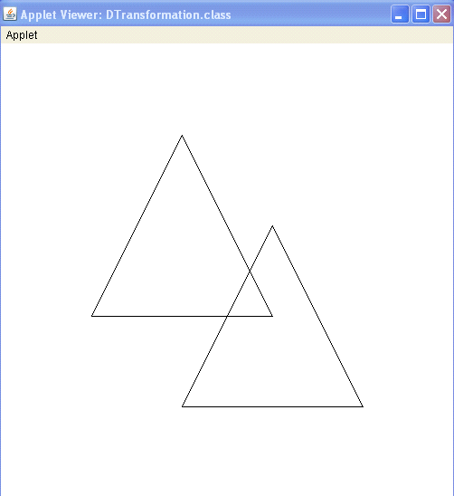

Microsoft Windows XP [Version 5.1.2600]

(C) Copyright 1985-2001 Microsoft Corp.

C:\Documents and Settings\Administrator>cd/

C:\Documents and Settings\Administrator>d:

D:\>cd glancy

D:\glancy>javac Dtransformation.java

D:\glancy>appletviewer Dtransformation.java

Enter the no. of vertices : 3

Enter co-ordinates for 1:

50

300

Enter co-ordinates for 2:

250

300

Enter co-ordinates for 3:

150

100

1: Translation

2:Scaling

3: Rotation

4:reflexion

Enter your choice : 2

Enter <Sx> value : 2

Enter <Sy> value : 1

Enter Reference Vertex : 1

Do you wanna coninue? y/n :

